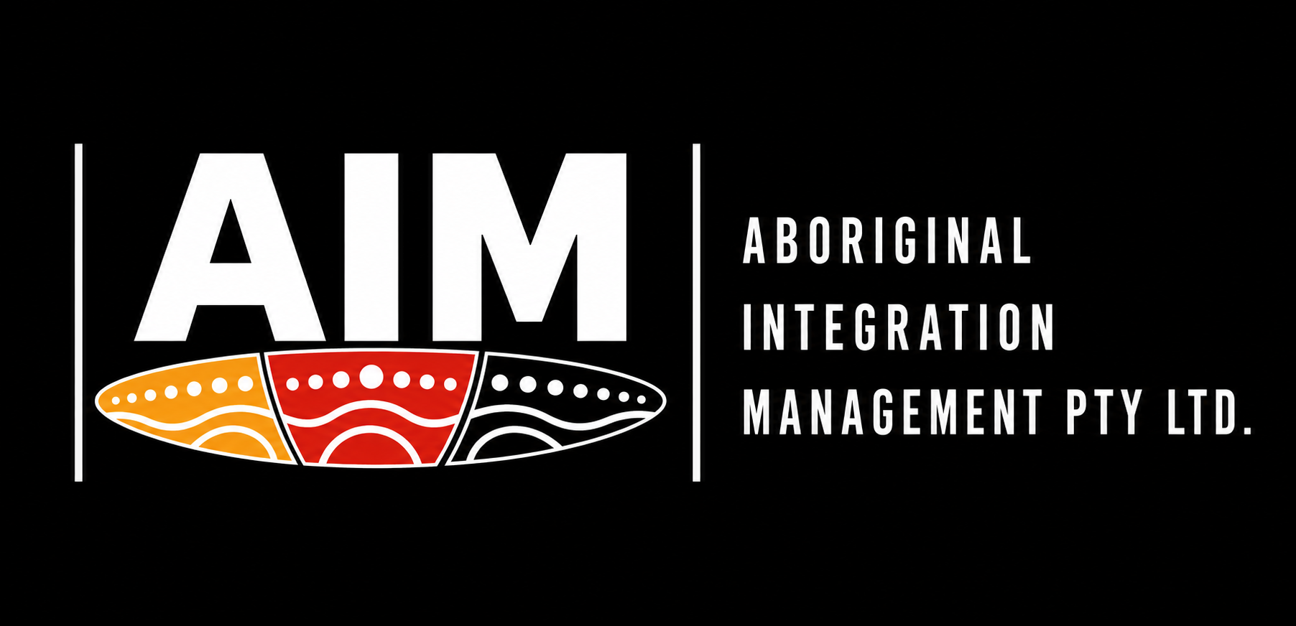
BUILDING STRONGER WORKFORCES
Creating measurable Aboriginal employment outcomes
Recruitment | Labour Hire | Mentoring | Workforce Development | Reporting
Corporate Capability Statement
Prepared for major projects, Tier 1 contractors and procurement teams

ABOUT AIM
Workforce solutions with measurable Aboriginal employment outcomes
Aboriginal Integration Management (AIM) is a 100% Aboriginal-owned workforce solutions provider helping organisations attract, retain and develop skilled employees while creating measurable Aboriginal employment outcomes. AIM combines recruitment, labour hire, mentoring, mobilisation support and reporting to help clients build safer, more stable and more accountable workforces.
What AIM does differently  • Builds workforce capability, not just short-term placements.  • Supports workers through structured mentoring and practical problem solving.  • Gives clients clear reporting for workforce participation, retention, issues and outcomes.  • Works with supervisors to identify risks early and keep people engaged, safe and job-ready. | AT A GLANCE  ✓ 100% Aboriginal-owned  ✓ South Australian business  ✓ Labour hire & recruitment  ✓ Mentoring & retention  ✓ Compliance & mobilisation  ✓ Workforce reporting  ✓ Indigenous procurement support
AIM helps clients demonstrate genuine social value through employment, not just paperwork.

CORE SERVICES
What we deliver for clients
Workforce Recruitment  Candidate sourcing, screening and job-readiness support.  Client value: less friction, clearer accountability and stronger retention. | Labour Hire  Flexible workforce supply with payroll and employment administration.  Client value: less friction, clearer accountability and stronger retention.
Aboriginal Mentoring  Ongoing worker engagement, wellbeing support and retention focus.  Client value: less friction, clearer accountability and stronger retention. | Mobilisation & Compliance  Medicals, D&A, inductions, licences, onboarding and site-readiness support.  Client value: less friction, clearer accountability and stronger retention.
Reporting & Evidence  Weekly and monthly reporting for participation, mentoring, issues and outcomes.  Client value: less friction, clearer accountability and stronger retention. | Workforce Planning  Training pathways, retention strategies and leadership development.  Client value: less friction, clearer accountability and stronger retention.

PROCUREMENT-READY
What major clients look for
Major contractors and large organisations want suppliers who reduce risk, support safety, demonstrate capability and provide evidence. AIM's capability statement is structured around the things procurement, project teams and community/social value teams commonly assess.
Safety & fitness for work | Workers prepared, checked and supported to meet site expectations.
Compliance discipline | Onboarding, licences, site requirements and documentation managed clearly.
Capacity to deliver | Practical workforce supply supported by mentoring, supervision engagement and reporting.
Social procurement outcomes | Genuine Aboriginal participation, retention and development outcomes clients can evidence.
Ethics & Governance | Transparent communication, confidentiality and accountable escalation pathways.
Continuous improvement | Workforce issues converted into practical actions, training and improved retention.

THE AIM MODEL
Recruit. Employ. Mentor. Report. Retain.
01 | Recruit | Source and screen candidates aligned to client roles and site requirements.
02 | Prepare | Confirm licences, tickets, medicals, D&A, PPE, payroll and onboarding requirements.
03 | Mobilise | Coordinate start dates, site inductions, rosters and supervisor communication.
04 | Mentor | Maintain regular worker engagement, welfare support and workplace guidance.
05 | Report | Provide concise updates on attendance, engagement, risks, outcomes and actions.
06 | Retain | Support long-term workforce stability, training pathways and leadership development.

A STRONGER MODEL
Traditional labour hire compared with AIM
Traditional labour hire | AIM workforce partnership
Supplies workers | Builds workforces
Recruitment only | Recruitment plus mentoring
Limited follow-up | Regular worker and employer engagement
Reactive issue handling | Early risk identification and escalation
Basic placement reporting | Evidence-based workforce and procurement reporting
Short-term fill | Long-term retention and development
AIM is designed for clients who need workforce outcomes they can see, measure and report.

INDUSTRY CAPABILITY
Where AIM can support
Civil construction | Major infrastructure | Defence & shipbuilding
Mining & resources | Manufacturing | Utilities & energy
Facilities management | Transport & logistics | Government projects
Asset maintenance | HVAC & trades | Community employment pathways
AIM can support clients with labour hire, candidate pipelines, Aboriginal workforce participation, mobilisation coordination, mentoring, reporting and workforce retention across project-based, operational and long-term employment environments.

CONFIDENCE FOR TIER 1 CLIENTS
The proof points clients want to see
Workforce readiness  Pre-placement checks, site readiness, role expectations and practical candidate support. | Safety focus  WHS commitment, PPE awareness, fitness-for-work expectations and incident escalation.
Reporting discipline  Clear evidence of workforce engagement, mentoring activity, retention risks and actions. | Cultural accountability  Culturally respectful mentoring, family/community awareness and practical support.
Client communication  Regular contact with supervisors and project contacts to keep issues visible early. | Continuous improvement  Review of workforce barriers, training opportunities and retention improvement actions.
Procurement alignment note: large clients such as infrastructure contractors, resources companies and defence primes commonly prioritise safety, ethics, compliance, supplier capability, sustainability, social procurement, Indigenous business engagement and clear reporting. AIM has been positioned around those assessment areas.

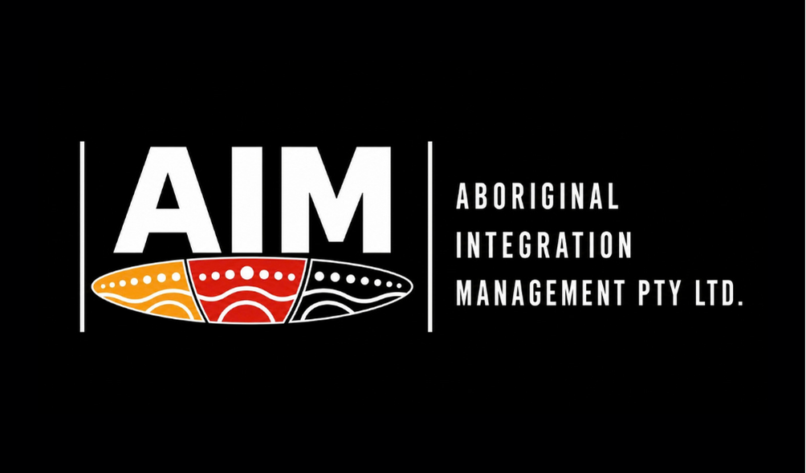  TOGETHER, CREATING ABORIGINAL EMPLOYMENT OUTCOMES | Let's build your workforce together  Bella Zimmermann  Workforce & Client Partnership Coordinator | Aboriginal Integration Management Pty Ltd  Mobile: 0418 432 538  Email: bella@aim4success.com.au  Website: www.aim4success.com.au  ABN: 39 684 265 736  Recruitment | Labour Hire | Mentoring | Workforce Development | Reporting  Prepared for business development meetings, tender introductions and procurement conversations.

